**JAISHREE S 231901011**

**EX:10A**

**DATE: 18/09/24**

**CUSTOMIZED PING COMMAND TO TEST THE SERVER CONNECTIVITY**

**AIM**: to ping command to test the server connectivity from os import system

print('1. Ping Google')

print('2. Ping Yahoo') print('3. Ping custom URL') while True:

key = int(input('Input your choice: ')) if key == 1:

system("ping [www.google.com")](http://www.google.com/) elif key == 2:

system("ping [www.yahoo.com")](http://www.yahoo.com/) elif key == 3:

url = input('Enter URL: ') system("ping " + url)

else:

print("Invalid Option!")

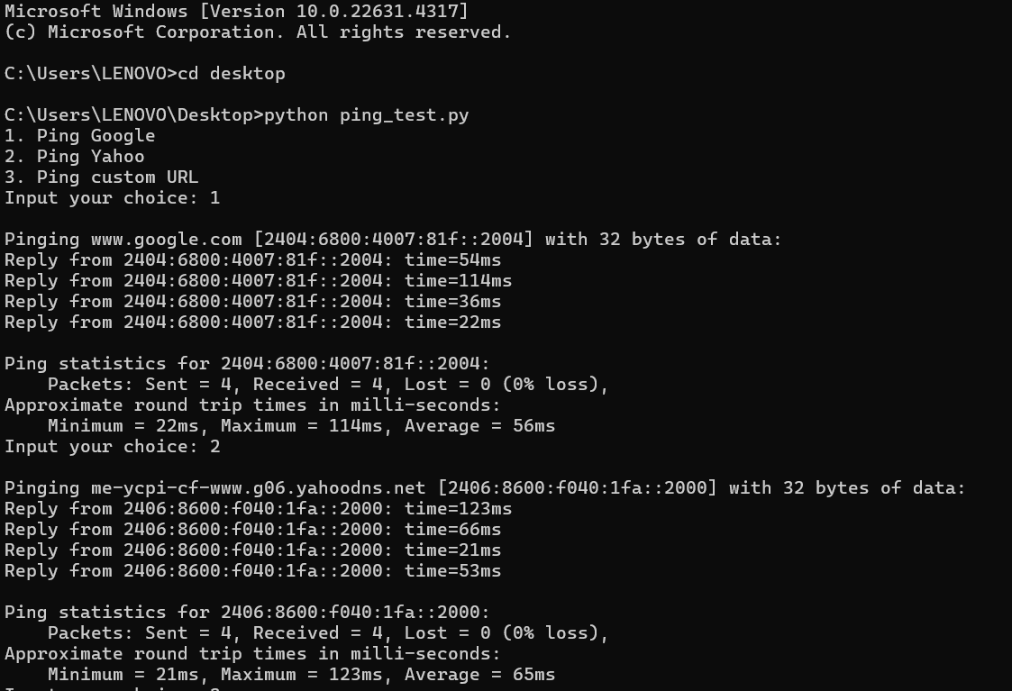

**RESULT:** Server connectivity has been tested using ping command

CSE(CYBERSECURITY)2ND YEAR